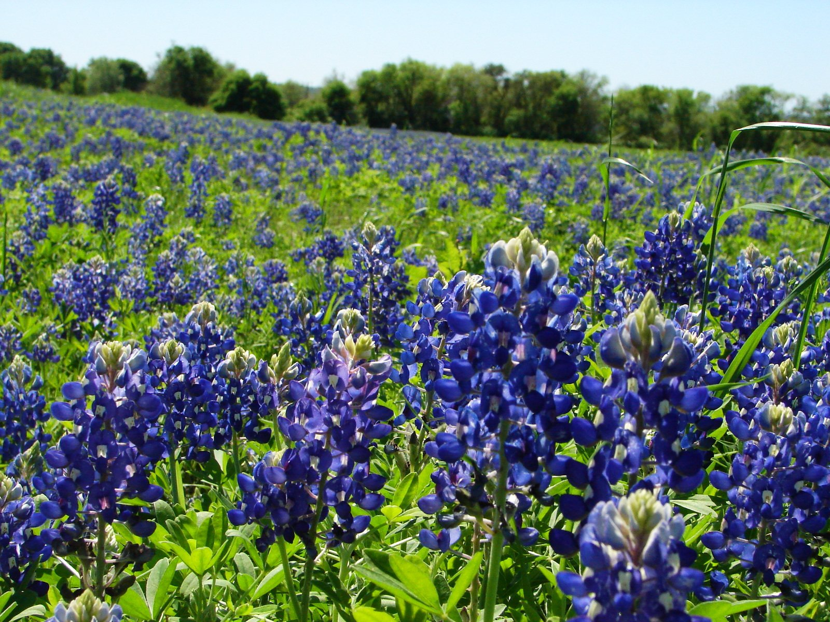
$60 per person includes transportation and festival entrance, does not include lunch
Depart FUMC 9:00am
Return around 4:30pm

